**BCS 231040**

**Name : laiba bibi**

**Practice task 2**

#include <iostream>

using namespace std;

void eliminateEvens(int* arr, int size) {

for (int i = 0; i < size; ++i) {

if (*(arr + i) % 2 != 0) { // Check if the element is odd

if (*(arr + i) > 0)

*(arr + i) += 1; // Add 1 to positive odd values

else

*(arr + i) -= 1; // Subtract 1 from negative odd values

}

}

}

void displayArray(int* arr, int size) {

for (int i = 0; i < size; ++i) {

cout << *(arr + i) << " ";

}

cout << endl;

}

int main() {

int values[10];

cout << "Enter 10 integer values: ";

for (int i = 0; i < 10; ++i) {

cin >> *(values + i);

}

eliminateEvens(values, 10);

cout << "Updated array: ";

displayArray(values, 10);

return 0;

}  
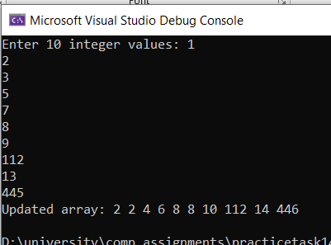

PRACTICE TASK 3

#include <iostream>

using namespace std;

void calculateAreas(double* radius, double* area, int size) {

for (int i = 0; i < size; ++i) {

*(area + i) = 3.14 * (*(radius + i) * *(radius + i));

}

}

void displayArray(double* arr, int size) {

for (int i = 0; i < size; ++i) {

cout << *(arr + i) << " ";

}

cout << endl;

}

int main() {

double Radius[10];

double Area[10];

cout << "Enter 10 radius values: ";

for (int i = 0; i < 10; ++i) {

cin >> *(Radius + i);

}

calculateAreas(Radius, Area, 10);

cout << "Calculated areas for the circles: ";

displayArray(Area, 10);

return 0;

}

